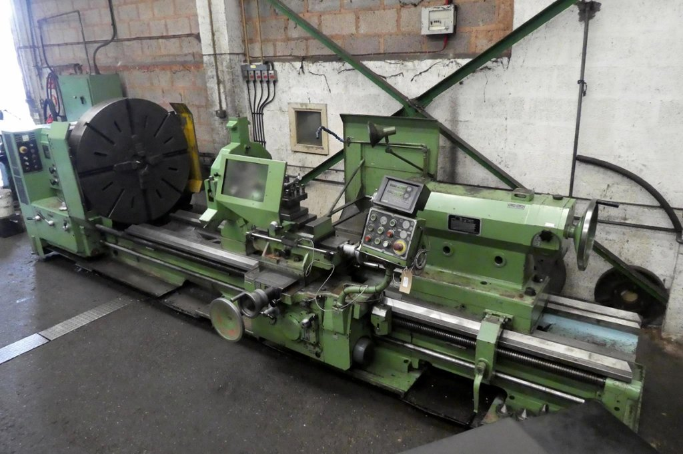
Poreba TR115 B/3M Gap Bed Lathe,
Serial No.7402-01-13013-01
Year of Manufacture1994
Height of centres 580mm
Between centres 3000mm
Swing over bed 1150mm
Swing over cross slide 800mm
Swing in gap 1480mm
Rapid traverse Longitudinal 4000mm/min, Cross 2000mm/min
Spindle speeds5 - 500 rpm
Spindle bore 120mm
Tail Stock 190mm
Quick change gearbox Metric, Modul, Inch
Gap piece casting 350mm
Gap in front of face plate470mm
Bed type Double vee
Input 400/440/3/50hz
Pitch of lead screw 12mm
4 jaw chuck 1250mm
Tool post 4 way
Dials Metric
Digital read out Newall Sapphire 2 Axis
Fitted with Chuck guard, coolant. splash guard
Length 6150mm
Width 1900mm
Height 2000mm
Nett weight actual.12,220 Kgs. / 12 Tons. Price £37,500.00+vat

